

Swindon Makerspace
Membership Guide

About this Guide
This is a simple guide to your membership benefits, the associated rules and other useful information about the operation of the Swindon Makerspace (hereafter referred to as the Makerspace).

The Makerspace is run entirely by its members and as such, we really want to keep the number of rules to a minimum. We can only do this if members and visitors observe the spirit, not just the letter, of the rules - they are here firstly for your safety, and secondly to prevent annoyance to other users of the space.

This guide is split into several sections, covering your membership benefits, the rules of the space, the code of conduct and various policies.

This guide and our Makerspace community are constantly evolving - see the details of how to get involved in the “How your membership works” section.

Contents
- Overview of the Makerspace
- Rules and Benefits
- How your membership works
- Code of Conduct
- Policies

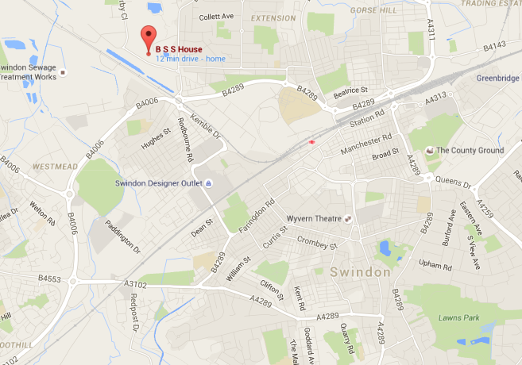
Overview of the Makerspace
Swindon Makerspace CIC is a not-for-profit shared workspace located at:

Unit 34, BSS House
Cheney Manor
Swindon
SN2 2PJ

Run by its members, for its members, with all proceeds reinvested - underpinned by a social enterprise model that aids continuous growth and expansion.

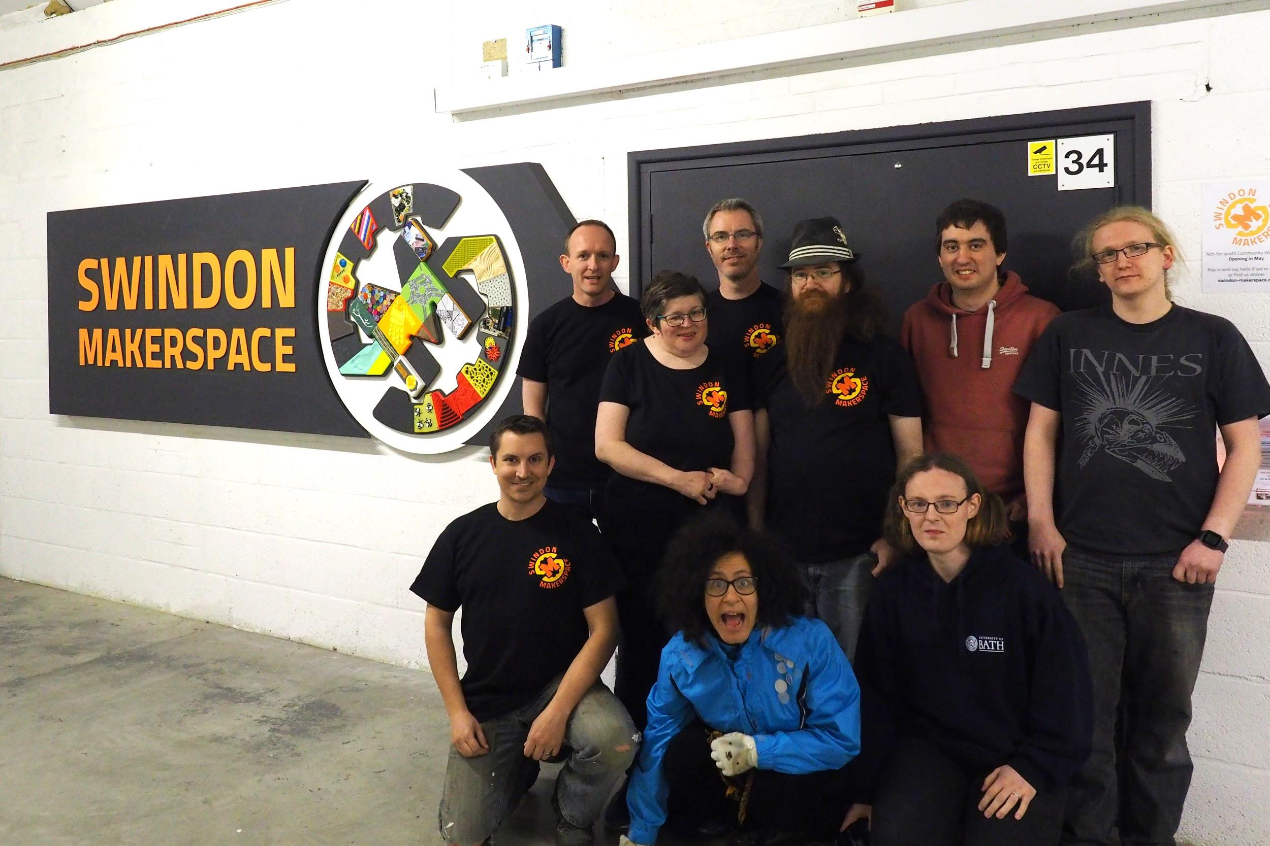
Community Interest Statement
Our objective is to provide a place for individuals who want to make, innovate or socialise with like minded “makers”, and support members from the community who are interested in exploring, learning and innovating with a variety of techniques and materials by:

- Establishing a sustainable, open maker facility - accessible 24x7 to all members
- Providing a space that's bookable by other clubs/societies
- Facilitating open and free sharing of knowledge, skills and inspiration between members, and non-members alike
- Organising regular community events with a S.T.E.M. focus (e.g. workshops, open days, demonstrations)

See our full CIC statement and associated annual reports on github.

The Space
The space is a 600 sq ft industrial unit, containing four “zones” and a kitchenette:
- Clean - Set of desks for computing, electronics and light crafts
- Wood - Woodworking bench and collection of hand/power tools
- Metal - Mill, lathe, welding gear and other metal-working tools
- Electronics and Fabrication - Long side bench with prototyping and test equipment

Most furnishings/equipment are mobile to allow the space to be reconfigured for different uses

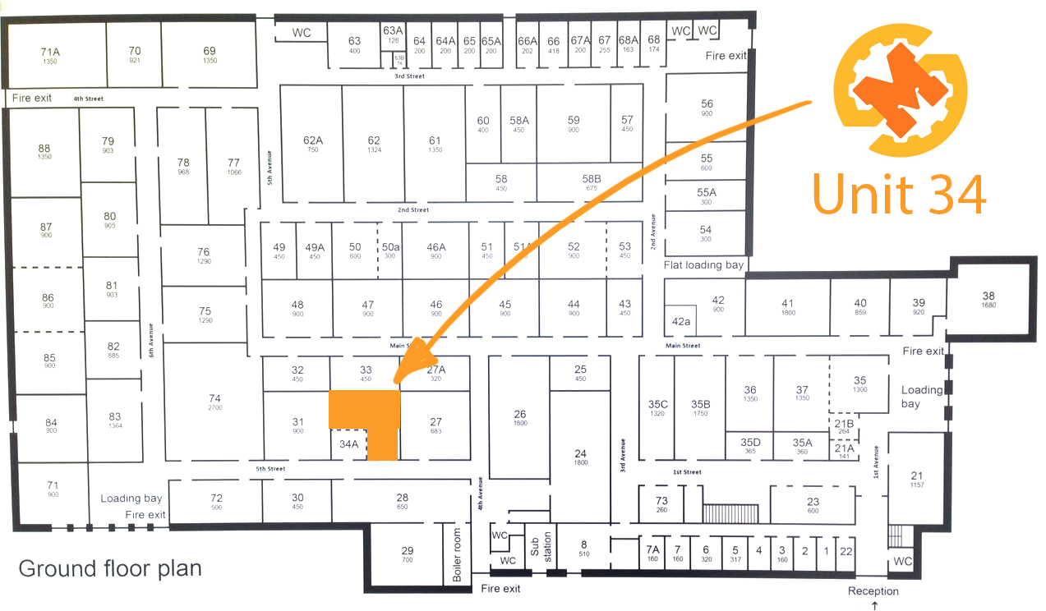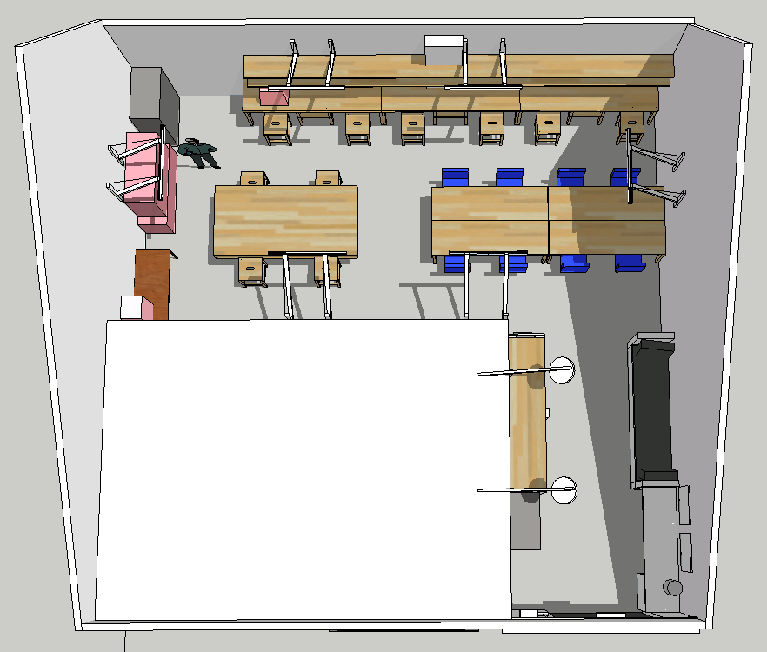

Directors
We have an annually elected board of directors, whose job it is to make sure that things happen in the Makerspace, that official practicalities are dealt with, that problems are resolved and that member’s voices are heard. They have the same voting rights as any other member of the Makerspace.

At present the directors are:

- James Mastros
- Jess Robinson
- Damian Axford

They can be contacted via the online community, in person most Wednesday evenings or by email: info@swindon-makerspace.org.

It takes a lot of work to manage, expand and generally make the space a great place to be - please volunteer to help where you can, lead initiatives, etc.

If you’d like to become a director, or want to know more about the formal setup of the Swindon Makerspace CIC, please refer to our Articles of Association on github: https://github.com/snhack/documentation/tree/master/legal

Rules & Benefits

Accessing the Makerspace & Security
- All members are treated as “keyholders” and will be granted 24x7 access to the space via an RFID keycard
- You may enroll using an existing RFID card, or you can be issued a dedicated card when you register as a member. You can even enroll multiple cards if you want to.
- Directors have physical keys and can be contacted in an emergency (e.g. power cut)
- Access to BSS House out of hours (after 8pm or before 7am) is via key code at the main entrance - the code will be given to you when you enroll
- Parking at BSS House is free, albeit the car park may be busy during weekday working hours
- Please be mindful that the space contains high-value equipment and personal property of various members - keeping the space secure is everyone’s responsibility!
- Do not leave the main doors open if unattended
- Ensure the main door is properly locked when you leave
- Ensure lights, heating and equipment is turned off when you leave (excluding infrastructure)
- We use CCTV to monitor the space, please do not obscure the cameras. Associated Data Protection registration reference: ZA196492
- The door codes, keys, and RFID cards must not be given out to any individuals who are not Makerspace members

Etiquette
- Do not treat the Makerspace like your home, it is a shared space
- If you make a mess, tidy it up
- Workbenches should be left in a fit state for the next user
- Please put tools back where they belong, or at least where you found them.
- Clean your dirty cups and plates in the sink before leaving the space. Don't leave them lying around - there is no cleaner!
- Any items left on a workbench overnight become fair game. Put your stuff back in your box.
- If you have engaged in any waste generating activity (e.g. peeling wires), hoover or sweep the spot.
- Please do not bring bikes into the space unless you are working on them, they take up too much room. There are bike racks inside BSS house near to the Makerspace entrance.
- Respect other member’s space, property, etc.
- Do Not Hack - means Do Not Hack
- Sleeping in the Makerspace property is forbidden
- Be aware that member’s private details are sometimes available on the online services we use, or on contact sheets (email, private phone number, etc.) - please do not give out other member’s details without permission.
- If you continually annoy or endanger others by ignoring these rules, the directors have the right to impose sanctions, as described in the Making a Complaint section. It is not something they want to do.
Pets (e.g. dogs) are welcome in the space, but are the owners responsibility to keep out of mischief and clean-up after… and no, they can’t use the equipment :)

Health & Safety
- Do not be on fire!
- Electrocution of any kind is prohibited.
- Don't use tools or equipment unless you're sure you know how to do so safely. If you see someone working in an unsafe way, it's your duty to stop them and let them know
- Don't defeat or hack safety features/equipment. This is for other people's safety as much as your own. Do not bypass the access control -- it is a safety feature!
- Check the website for instructions. Read the warnings. If in doubt, ask
- Don't put others and yourself in danger! Use safety equipment where appropriate. Make sure you are in a fit state to use the equipment. Be mindful of anyone around you - they might not be paying attention and/or wearing appropriate safety gear (e.g. safety glasses)
- If you do get hurt, please fill in the accident book (located with the PPE gear above the fire extinguishers) and inform one of the directors

Community
- The Makerspace is more than just the physical location, it’s also about member community
- We stay in touch using a variety of online services, notably:
  - Google Groups: https://groups.google.com/forum/#!forum/swindon-makerspace
  - Telegram: https://telegram.me/joinchat/A5Xbrj7rku3FJlueOPF8vg
  - Twitter: @swindonmakers
  - Facebook: www.facebook.com/swindon.makerspace
- We have a website and wiki with more info on the space and its online channels
- We try to ensure major decisions are discussed in our regular Maker sessions, but there’s often a lot of discussion online first

Regulated and unregulated equipment
Some of the equipment is valuable, sensitive and/or dangerous (e.g. 3D printer, lathe), and needs some measure of training to use safely and without causing damage. These items are to be labelled as “regulated equipment”, differentiating them from all the minor tools (e.g. pliers, soldering iron).

- Unregulated equipment can be used by anyone, subject to:
  - You must have had an induction to the space
  - Be sensible, ask if you don’t know what you’re doing
  - You accept liability for any accidents (including damage to the equipment)
- Regulated tools are only to be used by members, and only once they’ve had an induction from an appropriately skilled existing member:
  - A list of members that can provide inductions is posted above each piece of regulated equipment - please contact them to arrange an induction
  - Once the induction is complete, you will need to self-certify that you feel competent to use the equipment - if you don’t feel competent, don’t use it!
  - Some of the members may be able to provide additional guidance or support - contact them directly or ask the group online
  - A record is kept of those who have been inducted
  - Power to regulated equipment is normally regulated by an access control node and requires your RFID badge to be inserted to power on
  - Using a piece of regulated equipment without induction is not permitted

Donations of Money
Donations of money are always welcome (!), and can be via cash (use the donations tin in the space), bank transfer or Paypal:

- Donations will be spent on items from the wish list (see wiki), which includes infrastructure for the space (e.g. furniture).
- If you’d like to see your donated money spent on a particular item (e.g. piece of equipment), consider organising a pledge drive instead.
- Donations of money in the form of “Paying membership fees up front” will be returned at the rate of the monthly membership fee (see Fees). Please note that in the unfortunate event that we run out of money and need to fold the business before these are fully repaid, the rest of the donation will not be repaid.

Donations of Physical Items
Before donating physical items, please check:

- Is it on our wishlist? (see the wiki) if the item is not on our wishlist then check with a director before bringing it into the space. If it is on the wish list then bring it in - thank you!
- Is it on our List of Unwanted Donations? (see the wiki) - If the item is on this list, we already have so many of them that we don't need any more (like CRTs)
- Will you be upset if it is thrown away? If it would be difficult for the average maker to comprehend the intrinsic hack-value of the item then it may end up in our 3 week disposal process. Large items that will not fit through the disposal process could get thrown out without warning. If this does not appeal then it might be better not to donate the item.
- Will you be upset if it gets sold? We might decide that something you’ve donated isn’t right for us, but might get us some money that we can make better use of. If this would upset you, consider loaning it instead. Directors will make the call to sell something, and discuss it with the group online before making the final decision.
- Does it meet any of the following criteria? - If it doesn't then we probably do not want or need it currently - but thanks for thinking of us!:
  - Item is a tool useful for the types of hacking that take place at the space
  - Item is a common part/component that is not scrap
  - Item is in working order and has a reasonable resale value
  - Item can be easily stripped for high value parts
- Will the Makerspace accept the donation? - if you bring items to the space with the intention of donating them without first making sure that the organisation is willing to accept the donation (as decided by consensus on the mailing list) then the items are still in your ownership, and it is your personal responsibility to dispose of them once you're asked to do so. This is especially true for large items, or items that require unusual means of disposal (e.g. toxic materials.)

If you have a particularly rare or unusual old piece of computing hardware, we refer you to the Swindon Museum of Computing in the town centre who may be interested.

Loaning items to the space
- Several members have loaned some of their tools/equipment to the space for all members to use, the only difference vs donated equipment is that they retain the ownership and can remove them from the Makerspace at any time
- Using loaned equipment is the same as for any other equipment in the Makerspace
- If you would like to loan something to the space, please discuss it with one of the directors
- Please ensure loaned items are clearly labelled with Do Not Hack and Loaned By stickers
- Loan items also need to be officially logged onto our asset register to ensure they are protected by our insurance

Selling Stuff to other Members
- You’re welcome to offer items/services for sale to other members - just don’t be a nuisance
- Posting items for sale on the groups is the recommended approach
- Consumables could also be added to the mini-bar

Mini-bar
The Mini-bar is a collection of consumables (electronics, raw materials, etc) that are currently owned by various members, but haven’t yet been used in a project. Mostly made up of all those interesting things we buy and then never get round to using!

- The Mini-bar is kept locked at all times, access is granted via RFID
- Contents of the Mini-bar are posted on the wiki (which should be fairly up to date), or you can ask someone to open the Mini-bar to have a browse
- Items in the Mini-bar should be clearly labelled with who owns them and their value (price tag)
- If you’d like to buy an item, either organise it with the owner directly or place the right cash into the box with their name on it
- Please do not take any items from the Mini-bar without paying the owner!
- Larger items may not fit in the box (e.g. aluminium profile), but should still be clearly marked with owner and price tag
- Feel free to add some of your own items to the Mini-bar
- Items in the Mini-Bar are managed by the space, asset logged and therefore covered by our insurance policy

Pledge Drives
- Sometimes we run pledge drives, which may be for money or equipment.
- You will see these announced in our online community and posted in the space.
- You may ignore these if you wish - you are under no obligation to pledge.
- Pledge drives are instigated at the desire of members, agreed with the directors and are intended to serve the best interests of the space and its members - ultimately, it’s how we got going in the first place!

Personal Items
- Members are allowed to store personal items in the space, but they must be kept in one of the plastic boxes, labelled with your name and membership number. One box per member. Empty boxes may be recycled for other members if needed
- Larger/more items may be allowed, but please note that space is limited - requests for large items should be addressed to one of the directors. If your request is approved, items should be clearly labelled as yours with a Do Not Hack sticker
- If you would like your personal items to be covered by our insurance, then you need to itemise them and submit a log for our asset register - high value items may require an additional fee to cover the associated premium (1% of value)

Managing and maintaining the Makerspace
- If something is broken, fix it; don’t complain. If you can’t fix it, tell one of the directors ASAP
- If you break something, and you were being stupid - you’re expected to foot the repair bill and/or organise the repair. Accidental damage is covered by our insurance policy
- If you’re doing something major (e.g. changing furniture), share it and ask permission first
- If you think something should be thrown out, put a red tag on it and fill in the relevant details. Three weeks later the item will moved to the trash
- If something is too big to fit in the trash box, you should probably post to the list about it
- If you want to throw something away which looks useful, make sure the mailing list is informed well in advance

Friends & Family
- Members are welcome to bring their children to the space (see Fees), as long as they remain supervised and do not use the regulated equipment
  - Please be mindful that the space contains many potential hazards, especially for children!
  - Please respect the other users of the space (e.g. don’t let your kids run riot!)
  - Children are defined as anyone under 18
- Misbehavior by your children/guests will be considered as misbehavior by you.
- Friends/guests can be brought into the Makerspace for a small fee (see Fees), they will be under the direct responsibility of the member and must not use regulated equipment, unless under direct member supervision
- Spouses are not entitled to free membership - they will need to take out their own membership if they want to use the space

Clubs & Societies
- We welcome other groups to share our space if they need somewhere to meet
- Co-ordinated groups are allowed to book the space (either the workshop or the clean area) for use in advance - bookings are managed by our directors, please contact them to request a booking
- Bookings can be up to three hours and must not overlap another event in the calendar
- Bookings will be added to our events calendar, so other members (and the public) are aware
- Bookings can only be made by members (i.e. one member of the club/society must be a member) and will incur a booking fee (see Fees).
- Regulated equipment can be used under direct member supervision or by prior arrangement with the directors (e.g. amateur radio group using the radio gear)
- Members who wish to use the space while a booking is running are asked to be considerate.
- Exclusive use booking is currently impractical, but may be possible in the future (e.g. if we can afford a mezzanine to divide up the space)
- We can accommodate a maximum group size of 12

Leveraging the Space for Commercial Use
- Is acceptable so long as it doesn’t monopolise use of the space/equipment
- We expect this type of usage to be for prototyping and/or discussion of ideas with other members - NOT using the space as your office (9-5, taking calls, hosting meetings)
- You will not get priority usage or space for this, and don’t expect other members to stay out of your way just because you’re doing “business stuff”
- There are minimal safeguards in the membership rules, but “abuse” will ultimately be monitored/rectified by the Directors

Events and Regular Meetings
- Every Wednesday evening from 6:30pm is Open Night - a general social gathering, where a lot of the members come together for a chat and to tinker with various projects. Members of the public are welcome to come and look around, talk to members and their first visit is free.
- We hold workshops and talks on a variety of subjects - you’re encouraged to get involved and give a talk, or run a show’n’tell
- We may waive the “On the Door” fee for talks, or conversely, increase the fee to reflect the cost of running the workshop. The choice of what to charge for an event rests with the directors (for ease of decision making), but all members have a say
- We attend local/national events, such as the Bristol Mini Makerfaire - volunteers to help organise and run these are encouraged
- Check out the events calendar here: https://www.swindon-makerspace.org/calendar

How your membership works

Fees

Fees for Individuals
- Membership is a rolling subscription that costs £25 per month, paid in advance by standing order
  - Each adult membership includes a named child
  - Additional named children can be added to an adult membership for £5 per month
  - We offer a 10% discount if you would like to pay for a year's membership in advance
- There is no contract term, if you want to cancel your membership, just stop your standing order
- If you cancel, then the current month’s subscription fee is non-refundable and your membership will expire at the end of the month
- A concession rate (50% discount) is available for OAPs, students and those on limited income subject to proof of circumstances (e.g. student ID card, Job Seekers card, or letter from DWP)
- You can also pay on the door on Wednesday evenings (“Open Night” from 6:30pm) if you don’t want to commit to full membership, however, this does not entitle you to use the regulated equipment
  - £5 for adults
  - £2.50 for concessions (inc. children aged 5-18)
- Members can bring friends/guests into the Makerspace at the rate of £5 per day per person. This also applies to times other than regular Maker session. See Friends & Family.
- Lighting/heating the space costs a lot - if you use the space a lot when no-one else is there, we may need to increase your membership fee to cover the costs - one of the directors would contact you if they thought this was likely!

Fees for Group Bookings
- Group bookings are normally charged at £15 per-session (up to 3 hrs duration) depending on type of usage (see Clubs & Societies)

When your membership starts, renews and ends
- Membership fees are due monthly. Pay in your first payment when you like, and your account will be activated as soon as the transaction has cleared. Your membership will expire exactly one calendar month later, so set up a standing order on the same day of every month to stay a member
- If you ever stop paying, your membership will expire exactly one month after your last payment
(We may give you some leeway for it to last just over a month, but this is us being nice, not policy)
- In all of the above, you can choose to pay yearly instead (with a discount, as noted above).

General information
- You must be 18 or over to be an individual member
- We will need to store your contact information (name, postal address and email address) for our financial records, to support member communication and to meet our insurance policy requirements. Please let a director know if your contact details change.
- Because of our CIC structure, becoming a member also means you become a guarantor and as such are liable for contributing £1 in the event the business becomes bankrupt - see the full Articles of Association for more information
- Do Not smoke in the Makerspace!

Making a complaint
- If you have a complaint, or grievance, about the management of the space or another member, please discuss it with one of the directors in person or via email. Their decision on how to handle the issue is final.
- If a suitable resolution can’t be reached, the directors have the right to terminate membership(s), with no refund of subscription fees. A decision to terminate a membership can only take place at a meeting of the directors as per the company's articles.
- See the Grievance Procedure in the Policies section for more detail

Insurance
The Makerspace directly manages three types of insurance:

- Contents:
  - Protects all equipment in the space owned by the Makerspace, on loan or formally recorded on our asset register
  - Payouts are on a “insured value” basis (i.e. you get back what you said it was worth)
  - The value of the policy is reviewed whenever there are major additions to the space (e.g. new tools). If you are storing something of high value in your personal items, please let the directors know so they can check the policy
  - There is no excess for contents claims - although repeated claims would affect our premium (and that of other hack/maker-spaces, as our policies are linked)
- Public liability insurance
  - £2 milion cover
  - Ensures members of the public are protected when visiting the space, or when we are exhibiting off-site
- Employer’s liability insurance
  - £10 milion cover
  - Ensures all members are personally protected in the event of any accidents and that any volunteer work is also covered
  - Note: that we do not have employees, but it’s still called employer’s liability

In addition, BSS House covers building’s insurance as part of our lease agreement.

Detailed insurance information can be found in our Google Drive: https://drive.google.com/open?id=175NOT_BiAbw_GO0XK3mvL2bEkpqgjNqXo7nEC6s88lg

Questions
- If you have any questions this guide hasn’t answered, or you have any request to make, the best place to ask is within the online community (Groups, Telegram, etc).
If your question is confidential in some way, please contact one of the directors by email or in person at a Maker session

Code of Conduct
Swindon Makerspace is an inclusive community where all our members and visitors should feel welcome. This code applies to everyone's conduct on all public communication channels (such as Telegram and mailing lists), as well as at the Makerspace itself.
This code of conduct is in addition to the Rules which cover safety and the ethos of the space:
- It is unacceptable to harass or discriminate against others for any reason
- Keep all communication civil and keep swearing to a minimum; if you can't make a comment politely and persuasively, don't make it at all. Your conduct reflects on the image of the Makerspace as seen by outsiders
- Public trolling is never appropriate
- Personal attacks will not be tolerated
If you ignore these guidelines you will initially be warned or moderated. Subsequent offences may result in you being banned from our online communities. Additionally, the directors may take further action under our Grievance procedure.
If you witness any persistent breaches of this code, or have any other concerns, please contact the directors. The directors are powerless to fix problems they aren't aware of.

Policies

Grievance Procedure
The directors have the authority to ban anyone from entering the space, and to strip anyone of their membership, but must only do so in circumstances where this is best for Swindon Makerspace as a whole.

We will only ban repeat offenders who persistently demonstrate unwillingness to cooperate. Throughout the process every effort will be made to keep clear and constructive communication between the directors, the offending party, and any other affected parties.

Introduction
- This policy applies to both members and non-members who use the Swindon Makerspace.
- A person may be banned from the space if they are in violation of the Rules or Code of Conduct, if they are causing persistent annoyance, or if they have the potential to harm other users of the space.
- Before the formal banning procedure is entered into, the directors must make every attempt to resolve the issue informally.
- However, in the case of direct physical violence towards any person in the space, a member has the authority to immediately ban the offender for one month and refer the case to the directors.

Process
- The offending party must be given at least two official warnings before being banned. At every stage, it must be made clear to the party where they are in this process.
- At every stage, the directors must be in agreement that allowing the user to continue to use the space would not be in the best interest of the organisation.
- At every stage, the directors must make their reasoning available to the offending party. They must also make as much details as is appropriate available to all members.
- By default, a ban will be for a year. At their discretion, the directors can issue a reduced ban period.
- Bans of more than one year may only be issued in extreme circumstances. The directors must review these bans yearly.
- If the offending party is a member, the ban will trigger the process to remove the member.
- When a person is banned, their right to access Swindon Makerspace is revoked. Any entry to the space without the prior, express permission of directors will be considered trespass.
- The directors must seek feedback from the community to ensure this process remains fair and balanced.

Health & Safety Policy

Statement of intent
It is the general policy of Swindon Makerspace CIC to provide adequate control of the health and safety risks arising from our activities:

- We will provide, maintain and oversee safe and healthy working conditions, equipment and systems of work for all members and visitors
- We will provide such information and supervision as is needed for this purpose
- We will implement suitable emergency procedures in case of fire or other significant incident
- We will ensure safe handling and use of hazardous substances, in line with COSSH regulations
- We will hold Public Liability Insurance

This policy will be reviewed and revised as necessary, no less than annually as part of our AGM.

Responsibility
- Overall and final responsibility for health and safety at all events and activities organised by the Swindon Makerspace CIC lies with the Directors. This responsibility may be delegated to a named volunteer for events or activities as deemed appropriate. This volunteer will be responsible for ensuring that this policy is upheld
- All members have a duty to:
  - co-operate with the Directors on health and safety matters
  - not interfere with anything provided to safeguard their health and safety
  - take reasonable care of their own and others’ health and safety
  - use equipment correctly in accordance with instructions
  - report all health and safety concerns to an appropriate person.

Risk assessment
- General Risk assessments of our permanent venue will be will be carried out annually by the Directors. Responsibility for observing the decisions made in the risk assessment lies with all members.
- The Directors will check at quarterly intervals that the action/s have been taken and the risks have been removed/reduced.
- Risk assessments for one-off events or activities will be carried out by the member who is planning that activity. That member is responsible for liaising with the Lead Volunteer in charge (may be the same person) to ensure hazards are dealt with as outlined in the risk assessment.

First aid and accidents
- A First Aid Box and eye-wash station will be permanently located in the space, along with other personal protection equipment (goggles, ear-defenders, etc). The Directors are responsible for checking the contents every quarter.
- All accidents are to be recorded in the Accident Book - the book is located by the first aid box.

Fire
- Foam and CO2 fire extinguishers will be located underneath the first aid and PPE equipment, in a central location within the space.
- Fire extinguishers will be inspected annually and serviced as appropriate
- Escape routes shall be well signed and kept clear at all times
- We will comply/join in with regular testing of evacuation plans as organised by BSS House

Reasonable level of risk
We will take steps to avoid unnecessary risk and very high levels of risk. However, some activities inherently involve some risk. Learning about, and employing, risk management is a necessary part of “making”. We therefore aim to protect our members from unnecessary and high risk, and provide guidance and support to help members manage risk for themselves.

